(Please go to Page 2 for the instructions and the Question of this Assignment.)

Student’s Answer Sheet
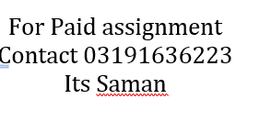
Student ID: | MC220200267
Digits of your Student ID: | 2 | 2 | 0 | 2 | 0 | 0 | 2 | 6 | 7
Paste script file in this box. [6 marks]
For Paid assignment
Contact 03191636223
Its Saman
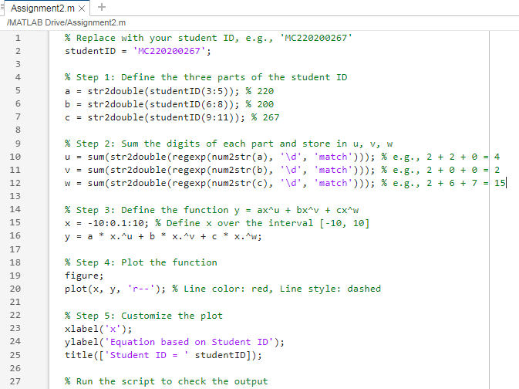
Paste output figure file in this box. [4 marks]
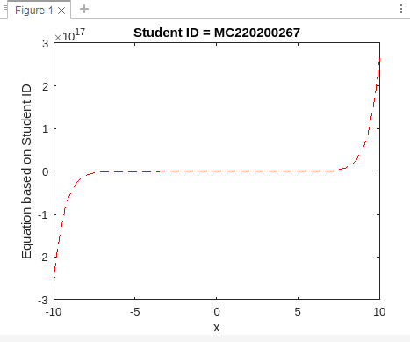

Assignment # 01 MTH643 (Fall 2024)
Total Marks: 10 Due Date: Nov 18 2024
DON’T MISS THESE: Important instructions before attempting the solution and submission of this assignment:
- Lectures 2-5 are covered in Assignment 1.
- All students (of both sections) shall complete this Assignment.
- All your answers, such as name, student ID, and MATLAB script and output figure files must be put inside the allocated boxes (fields) provided in the Student’s Answer Sheet.
- Only the Student’s Answer Sheet will be marked. So, you may choose to only upload your Student’s Answer Sheet. Answers written outside of the boxes may get Zero mark.
- Any copied work, for example, script and output figure of some other student’s ID will get Zero mark.
- Assignment 1 is due on Nov 18, 2024.
- Properly Upload the Student’s Answer Sheet completed in MS Word format on LMS as per the previous practice.

Question: Open MATLAB Software And perform the following steps:
- Create a new script in MATLAB software and save it with your student ID. For example, if the ID is BC210345678, the name of the script file will be BC210345678.m
- Split the 9 digits of your student ID into three 3-digit numbers. For example, if the ID is BC210345678, split it as 210, 345, and 678.
- Assign these numbers to variables a, b, and c respectively.
- Now add the digits in each variable (i.e. 2+1+0, 3+4+5, 6+7+8) and store them in variables u, v, w. (e.g. u=3, v=12, w=21)
- Create a function using their variables a, b, and c in a form. $y=ax^{u}+bx^{v}+cx^{w}$
- Plot the function as; Line Color: red, Line style: dashed. Interval = [-10,10]
- Each student’s plot will differ based on their ID values, making each plot unique.
- Label the x-axis as ‘x’
- Label the y-axis as ‘Equation based on Student ID’
- Give the figure a title of your student ID. For example: a student having ID BC210345678 will make title of ‘Student ID = BC210345678’
- Run the script to verify that everything runs right. And you will get the output figure of your work.

And then:
- Take a screenshot of the script file; copy and paste the screenshot in the box titled: Paste script file in this box. [6 marks]
- Take a screenshot of the output figure file; copy and paste the screenshot in the box titled: Paste output figure file in this box. [4 marks]

Very Important Note:
- The screenshots must be taken from MATLAB software. These screenshots must be taken along with their MATLAB headings and boundaries. See the sample below and your screenshots must be the same as provided in the sample below.
- Any student who will copy the commands from script file and saving the jpg of output figure and paste these in the answer boxes instead of pasting the screenshots will be awarded zero mark.

A sample of Student’s Answer Sheet:
- Please find below a sample Student’s Answer Sheet for a dummy Student ID: MC210345678.
- You will do all your work with your actual student ID. Otherwise; you may get Zero mark.
- Any student using this sample as his/her answer will also get Zero mark.

Student’s Answer Sheet
Student ID: | BC130212349
Digits of your Student ID: | 1 | 3 | 0 | 2 | 1 | 2 | 3 | 4 | 9
Paste script file in this box. [6 marks]
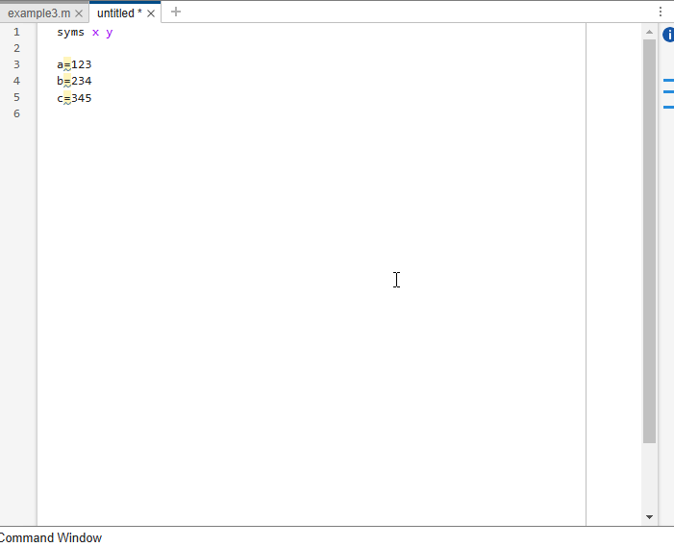
Paste output figure file in this box. [4 marks]


